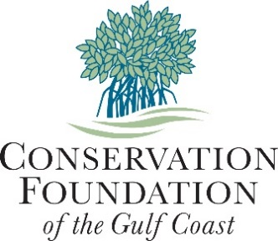

Lee County Legislative Delegation Meeting
400 Palmetto Avenue
P.O. Box 902
Osprey, FL 34229-0902
941.918.2100
conservationfoundation.com

October 18, 2017

Presentation by: Christine P. Johnson, President

- Support using “Florida Forever” funds for land and conservation easement acquisition: Protect natural Florida for people and wildlife; Protect land buffering waterways; Protect working lands.
- Benefits: Protects water quality and quantity; Essential for tourism and agricultural industries; Preserves unique Florida natural resources.
- Examples: Corkscrew Regional Ecosystem Watershed, Estero Bay, Charlotte Harbor Preserve State Park
- Opportunities: Additions and buffers to and inholdings in existing state parks and wildlife management areas:
  - Edison Farms addition to CREW (land)
  - Coral Creek in Charlotte Harbor Preserve State Park (land)
  - Myakka Ranchlands
    - Orange Hammock Ranch (land)
    - Murphy Marsh on Myakka River (easement)

- Support “Florida Community Trust” grants for parks and other public places.
- Benefits: Leverages local governments' and nonprofits' dollars to meet recreational needs of residents and visitors. Improves health by connecting people to nature.
- Examples: Caloosahatchee Creeks Preserve, Bay Preserve at Osprey, Robinson Preserve
- Opportunities: community parks and preserves providing water access and recreation, opportunities to enjoy and learn about nature.

Conservation Foundation of the Gulf Coast is a nonprofit conservancy working to save the bays, beaches, barrier islands and their watersheds in Manatee, Sarasota, Charlotte and Lee Counties.

Land Protection Priorities:
- Conserve habitat for imperiled plants and animals
- Protect shoreline and provide water access
- Connect conserved lands for people and animals
- Provide unique, highly desired recreational access for the public

BOARD OF TRUSTEES
Eileen Scudder-Zimmermann
James Westman
Glenn Shipley
Mickey Davis
Mario Bernardis
Robert W. Brown
Stephen Cetrulo
Ann J. Charters
Matt Drews
Harold L. Johnson, MD
Michael Knupp
Elizabeth Moore
Nora Patterson
David W. Young

BOARD OF ADVISORS
Fran Becker
Michael Biehl
Clyde Butcher
Edward E. Cohen, Ph.D.
R. Scott Collins
Daniel J. DeLeo, Esq.
James Ericson
Ann Garberding
Larry Garberding
Fredric C. Jacobs, Esq.
Pauline Wamsler Joerger
Chuck Johnston
Robert A. Kimbrough, Esq.
Helen Jelks King, OD
Richard Lawrence
Cornelia Matson
Jan Miller
John L. Minton, Jr., PE
Jackie B. Obendorf
Rob Patten
William C. Robinson, Jr., Esq.
Catherine A. Rustin
Peter Scanlan
Jeffrey Steinwachs
Arthur M. Wood, Jr.
FOUNDER
Albert G. Joerger, Ph.D.

PRESIDENT
Christine P. Johnson

