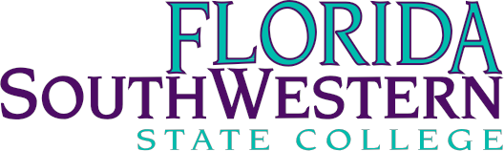

Dr. Jeff Allbritten, President (239) 489-9211
Mr. Matthew Holliday, Director, Governmental Relations (239) 826-7864

- Florida SouthWestern State College (FSW) supports efforts to expand access to affordable STEM-related certificates and degrees, including programs that meet Governor Scott’s “$10,000 Degree Challenge” for our limited workforce baccalaureates.
- Performance Funding
  - FSW supports measures addressing accountability and improvement that recognize the circumstances faced by our students.

Support the Council of Presidents request for system-wide funding to address new “high water mark” of enrollment & retention at your local public college.
  - Although the economy has begun recovering and enrollments have slightly declined, the Florida College System retains significantly increased enrollment over the course of the recent recession.
  - Total enrollment at FSW is up 44% or nearly 5,000 more students since fall 2006.
  - FSW Fulltime Equivalent enrollment is up 56.5% during the same period.
FSW only | Fall 2006 | Fall 2007 | Fall 2008 | Fall 2009 | Fall 2010 | Fall 2011 | Fall 2012 | Fall 2013 | 7-Year # Change | 7-Year % Change
Headcount Enrollment | 10964 | 11898 | 13309 | 16077 | 17280 | 17312 | 16052 | 15800 | 4836 | 44.1%
- Headcount – 15,800
- Full-Time Enrollment – 33.9%; Part-Time Enrollment – 66.1%
- 65.4% of students are 24 years old or younger, 34.6% of students are over the age of 24
- Female – 60.1%; Male – 39.9%
- 58.2% White, 26.7% Hispanic/Latino, 12.4% African American, and 2.7% other minorities
Florida SouthWestern State College continues to pursue 2+2 partnerships with our state universities:
- Enhanced partnerships with Florida Gulf Coast University focusing on Cybersecurity and Computer Engineering.

Florida SouthWestern State College supports the Department’s request for Public Education Capital Outlay funding of $57,311,626 for system-wide critical renovation, remodeling and construction needs.

Florida SouthWestern State College is an equal access, equal opportunity organization.
Florida SouthWestern State College provides students pathways that enhance credentials already earned, increasing employment potential.
- Advanced Technical Certificates (ATC) provide A.S. degree graduates further training and build their skills to make them more competitive in the workforce.
- Planned ATCs include Computed Tomography (CT) and Cancer Registry Management.
  - Industry trends are moving towards a requirement to have the specific CT certification in addition to the Associate in Science degree in radiologic technology.
    - Only five other Florida colleges offer the ATC in Computed Tomography.

Students find real success and real opportunity at Florida SouthWestern:
- Associate in Science/ Radiologic Technology
  - 100% pass rate on national licensure exam on first attempt for 10 years
  - 97% employment within six months of graduation for last five years

Florida SouthWestern State College offers 10 workforce related baccalaureates, 22 Associate in Science degrees, 14 certificate programs, and the Associate of Arts which transfers to any state university. Each and every one of the programs offered at FSW is focused on the workforce needs of our students and regional employers to place our graduates in careers that maximize the investment in education.

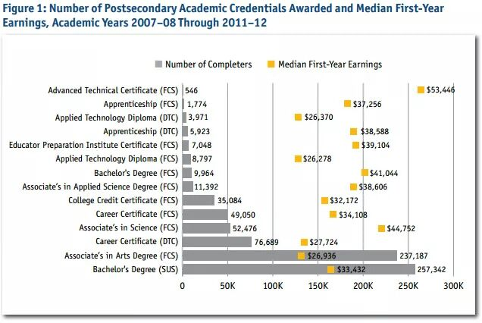
Florida College System:
413,318 credentials awarded over 5 years
$37,370 average median first-year earnings
http://www.air.org/sites/default/files/downloads/report/Florida%20Postsecondary%20Earnings%20Report%20Sept%202014.pdf

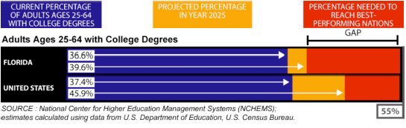
http://www.floridacollegeaccess.org/goal-2025/

