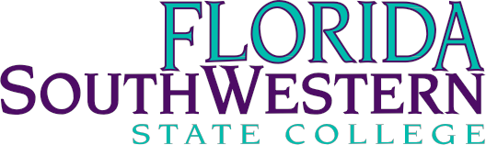

Dr. Jeff Allbritten, President
Dr. Robert Jones, Vice President, Economic Development & External Affairs
Matthew Holliday, Director, Governmental Relations

2019 Legislative Request
Support the Council of President’s recommendation for $292.2 Million to expand access to workforce education in the Florida College System
- $125 Million for Workforce Funding
- $87 Million for Student Success Initiatives
- $20.2 Million for Industry Certifications to fully fund at legislative intent of $1,000/certification
- $60 Million for Performance Funding (same as prior years)

$10,382,544 Operational Support to bring FSW to state average in per Full Time Equivalent funding
- FSW has been well below the average in state funding for several years
- Over the 5 previous years, $38.1million shortfall (2014/15-2018/19 projection)
- These funds could have improved advisor-student ratios and increased the number of full-time faculty positions and course offerings

Public Education Capital Outlay
$9,856,145 Renovation of Collier Campus, Buildings E&F to STEM focus
- These facilities, constructed in the early 1990s, are due for major renovations that will address safety/security upgrades, improvements to building environmental systems, modernization of technology, and classroom reconstruction to increase utilization of existing space
- This request includes funds needed to address the External Foam Insulation System (EFIS) which represents an ongoing maintenance concern
- Costs in construction have contributed to the higher cost for this request, along with the expansion in scope of work necessary to bring these facilities to appropriate levels of service (safety/security, as well as modernization)

$9,412,491 Renovation of Lee Campus Technology Building
- Funds requested would be used to complete a whole-building renovation of our primary classroom space for the delivery of technology programs
- The physical space renovations and the upgraded technology will allow a more comprehensive delivery of current & future STEM (specifically IT & Cyber) programming within an existing structure, increasing the return on investment for the taxpayers of Florida

