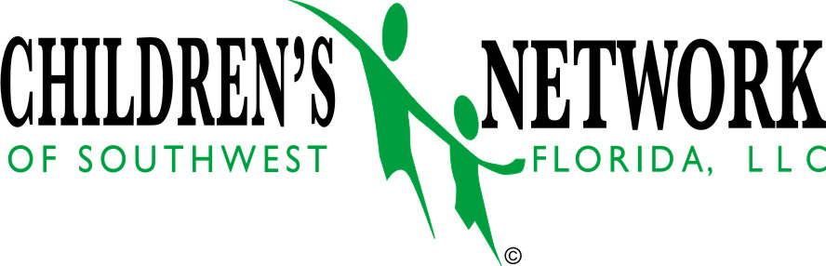

Lock-Out / DJJ / Cross-Over Youth
Fiscal Year 2013 / 2014

Total Kids 14
Total Cost $611,000.00
July 2014 through November 2014  Total Kids 13  Total Cost $436,000.00 | Fiscal Year 2014/2015 (Projected)  Total Kids 32  Total Cost $1,100,000.00

