Earn to Learn FL Pilot Program
(formerly known as Matched Savings for Education Program)
An Innovative and Responsive Solution to Community Needs
The Earn to Learn FL Pilot Program is a groundbreaking approach to helping low-to-moderate income students achieve their college graduation goals and do so with little or no debt. The program has already demonstrated remarkable results around the United States and here in Southwest Florida.
Earn to Learn FL works by combining student savings with scholarships, financial literacy, and success coaching. The program breaks down barriers to higher education and helps individuals and families escape the cycle of poverty and improve their earning potential.
Enlisting students as investors in their college success gives them a personal stake in their achievements. And empowering them with financial literacy training further ensures their ability to navigate their personal financial responsibilities and improve their economic mobility.

The Earn to Learn FL Pathway to College Success
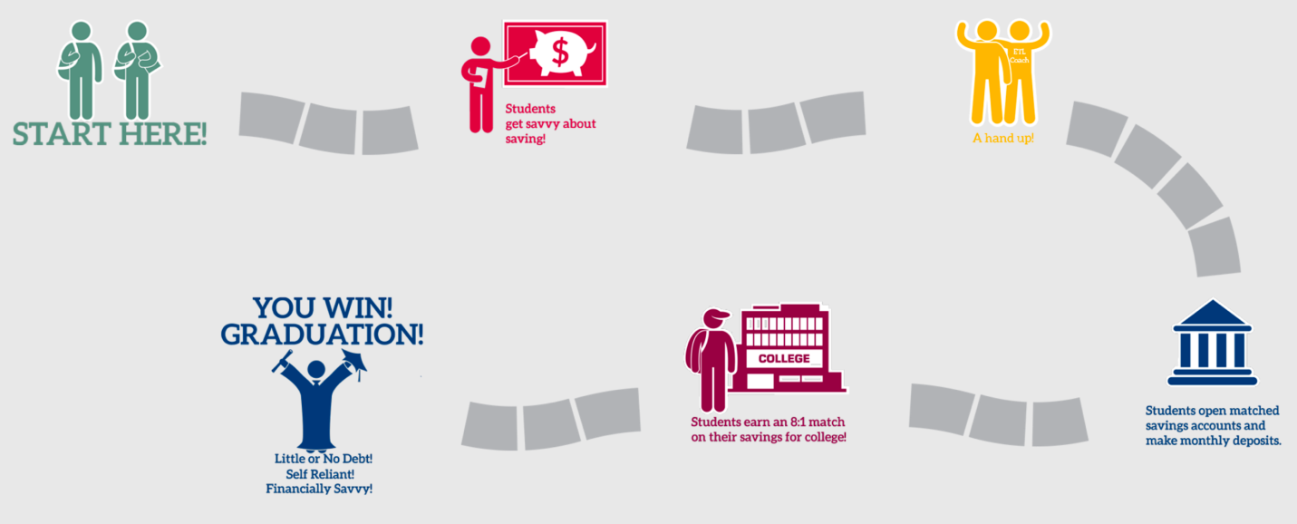
Women’s Foundation of Southwest Florida’s Role in Earn to Learn FL Pilot Program
The Women’s Foundation of Southwest Florida established its own Matched Savings for Education Program (MSEP) in 2016 with the support of federal and local private sector dollars, and the Foundation’s efforts have already demonstrated a scalable approach with excellent outcomes.
The Foundation’s MSEP has established 42 slots for qualifying students. To qualify, students must put $500 in a savings account over a period of six months and participate in financial literacy training. This amount will be matched by $4,000, half of which comes from the federal government and the other half from local private sector resources coordinated by the Women’s Foundation. Each year, up to 4 years, the student repeats the same process of saving $500 in order to receive the $4,000 match. The qualifying students have already entered college or university or have been accepted for enrollment. Once current funding is depleted, a waiting list of qualified students will be maintained for opportunities opened by future funding. As of August 23, 2017, the following results have been achieved:
- 330 registrants through our on-line portal
- 270 students qualified for the program
- >115 students started or completed required online financial literacy training
- 29 students have opened a savings account
- 6 students have met their $500 savings goal
To date, the qualified students are primarily from Lee County (53.2%) and Collier County (43.5%), with the balance from Charlotte, Hendry & Glades Counties.
Funding Proposal for Earn to Learn FL Pilot Program
Until federal funds for this program is restored, the Women’s Foundation is determined to assemble state, university, college and local philanthropic dollars to continue to expand the program in Florida and achieve successful outcomes. The Women’s Foundation is licensed to develop the Earn to Learn FL as a program to empower Florida’s low-to-moderate income students to successfully complete college on time and come out career ready.
To that end, the Foundation’s funding proposal is to initiate Earn to Learn FL to open 850 slots for qualified students attending a Florida state college or university. We are proposing that the Florida State Legislature appropriate $2 million for this Earn to Learn FL Pilot Program to be matched by another $2 million from a state college and/or a state university.

Earn to Learn FL qualifying students who make deposits for at least 6 months and meet their $500 savings goal prior to, or while, attending a state college and/or a state university, will earn $4,000 in matching funds to pay for tuition, books, and other credentialed course related expenses. Earn to Learn FL enrollment will be renewable for up to four years as long as students remain eligible and continue to save $500 each year.
Additionally, the program would utilize success coaching for students to include personal financial literacy training, college readiness training, aptitude evaluation, job placement and retention coaching, and ongoing support from the very first day of attending college all the way through graduation. The use of Earn to Learn FL savings accounts in conjunction with success coaching has been proven as a way to help individuals and families develop productive financial behaviors that increase the likelihood of finishing college with a degree and less debt, as well as be better prepared for post-college careers.
Why is it important to foster this initiative in Southwest Florida and beyond?
The 2016 United Way-Florida ALICE (Asset-Limited, Income Constrained, Employed) Report revealed that 44% of the households in Florida live in poverty or below the ALICE household survival budget threshold. Many individuals and families are working hard but falling short. One proven path out of poverty is wage advancement through the attainment of a degree or technical training.
In addition, the 2016 Status of Women in Florida by County: Poverty & Opportunity released by the Institute for Women’s Policy Research revealed that less than 20% of women over age 25 in Southwest Florida have obtained a bachelor’s degree or higher as opposed to 30.2% nationally and 26.75% in the State of Florida. We believe this program provides a solution to the barriers faced by low-to-moderate income people motivated to complete their education.
An 800% return on each student’s investment in themselves!!
Earn to Learn FL will target pre-screened and need based qualified students, either attending or admitted to a Florida state college or university. By offering an 8:1 match ratio and assuming an Earn to Learn FL saver’s contribution of $500 for education paired with the $4,000 match, at least 850 new slots could open up for economically disadvantaged students who want to achieve their dream of higher education.

Earn to Learn FL Pilot Program Budget Forecast
(5-year project*)

Income |  | Notes
State University Pledge | $1,000,000 | Pending State Appropriation
State College Pledge | $1,000,000 | Pending State Appropriation
State Appropriation | $2,000,000
Savings Accounts | $425,000 | 850 slots @ $500 per student up to 4 years*
TOTAL INCOME | $4,425,000
Expenses
Matched Savings ($4,000 each) | $3,400,000 | 850 slots @ $4,000 each student up to 4 years*
Saver’s Match | $425,000 | 850 slots @ $500 per student up to 4 years*
General Program Administration (7.5%) | $300,000
Non-Administrative (5.5%) | $220,000
Data Collection (2%) | $80,000
TOTAL EXPENSES | $4,425,000

*A student may renew this plan each year up to 4 years total to complete their degree on time and with minimum or no student debt

For further information, contact:

Brenda Tate
239-281-2233

